spray tans need love too.

# P R E C A R E :

do not apply any perfumes, lotions or deodorants

exfoliate your body prior to your tanning session

take a shower using only soap the morning of

shave a day before without applying moisterizer

wear dark, loose-fitting clothing. put a towel on your car seat to reduce transfer

avoid any spa services before your spray such as facial, mani, pedi

# P O S T C A R E :

wait at least 8-10 hours before showering

keep your skin moisterized

opt for loose-fitting clothing after your tan

limit pool and hot tub time

avoid oil-based products during the first few days

be mindful of shaving. shave gently and with a sharp, clean razor

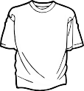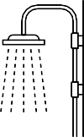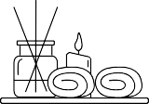

w w w . t o a s t e d c o c o n u t s b a r . c o m